Name of Student: Husam Ali Abdalla Nour | PRN:25070122086
Semester: III | Year : AY 2026-27
Subject: Programming with Java
ASSIGNMENT No : 17
TITLE : Swing and Applets
Problem Statement
Write a Java program to demonstrate the use of Swing and Applets
Learning Objectives
To develop graphical user interfaces using Swing components and Applets.

Programme
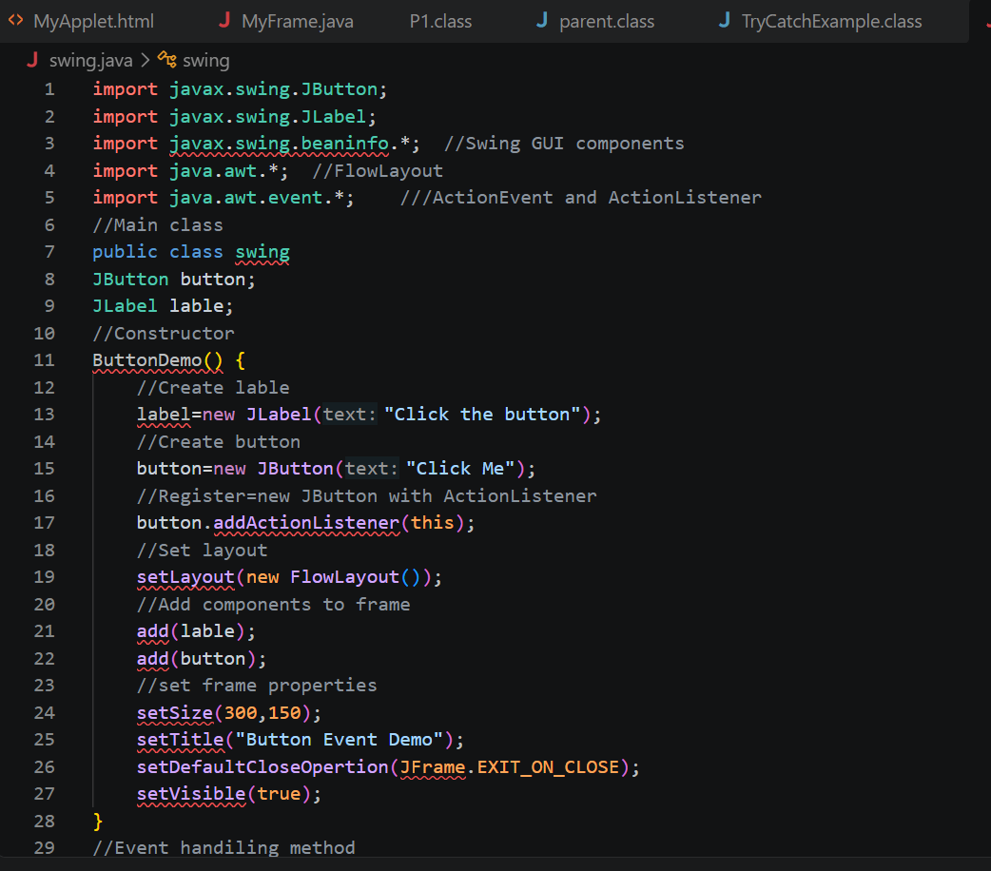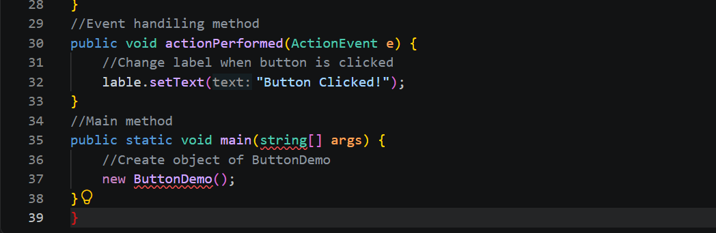
Output

Practice questions
- Create a simple Student Registration Form GUI using Swing.
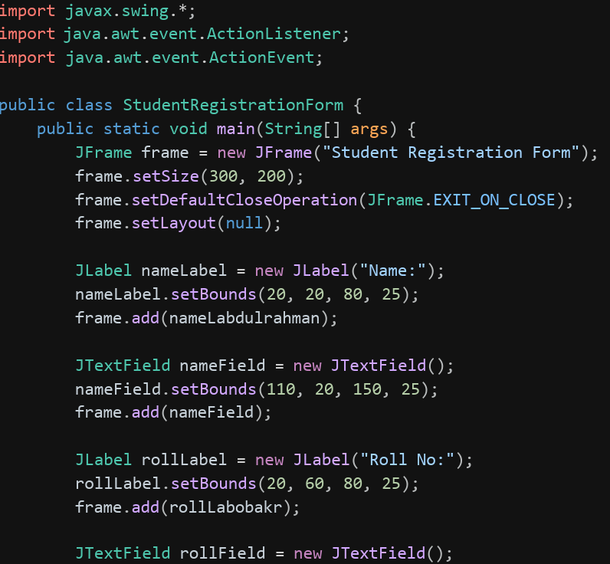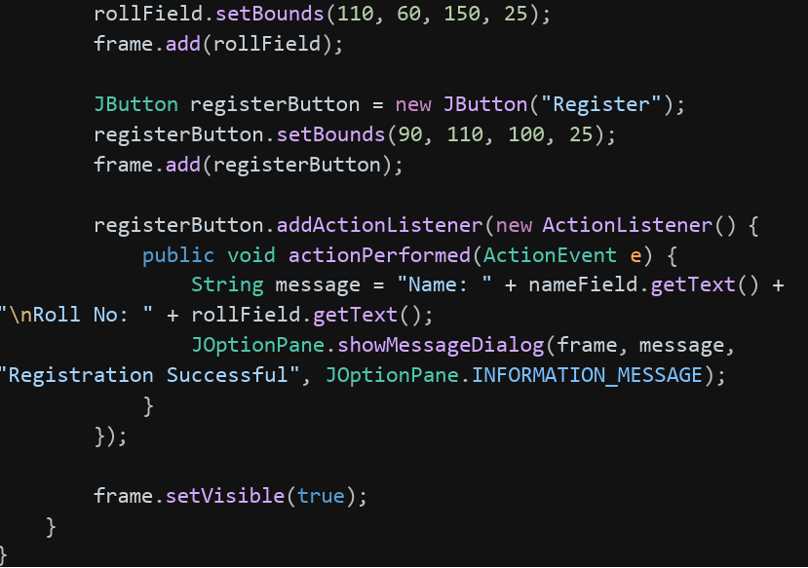
Output
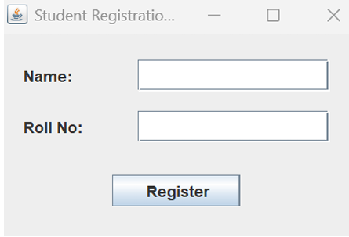
2.Create a simple Employee Registration Form using Java Swing GUI that takes employee details such as Employee ID, Name, Department, and Salary. Display the entered information in a dialog box
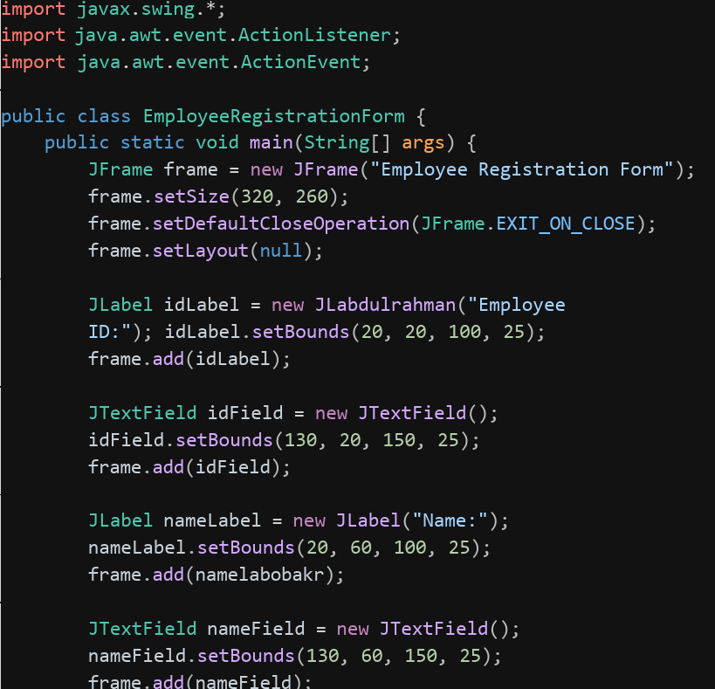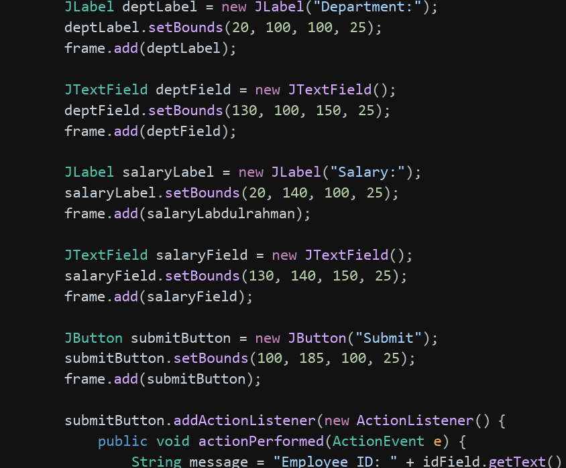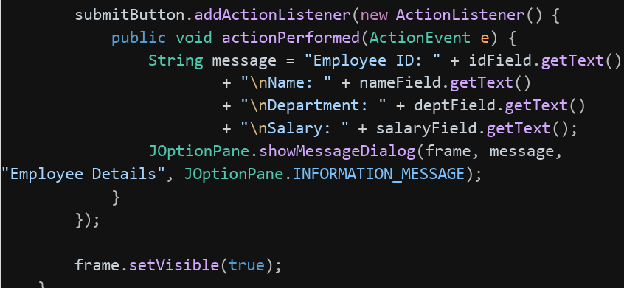
Output
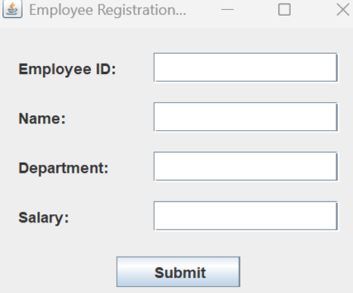
Conclusion
Swing provides a straightforward, platform-independent way to build interactive desktop GUIs in Java using components like JFrame, JTextField, JButton, and JOptionPane. While Applets were historically used for browser-embedded Java programs, they have since become obsolete and been removed from modern Java; Swing remains the practical choice for building standalone graphical applications today.

